<https://datatables.net/examples/api/add_row.html>

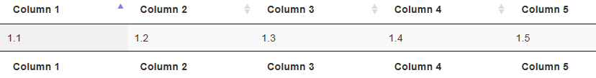

Load libraries

* [//code.jquery.com/jquery-1.11.1.min.js](https://code.jquery.com/jquery-1.11.1.min.js)
* [//cdn.datatables.net/1.10.7/js/jquery.dataTables.min.js](https://cdn.datatables.net/1.10.7/js/jquery.dataTables.min.js)

**Html**

<table width="100%" class="display" id="example" cellspacing="0">

<thead>

<tr>

<th>Column 1</th>

<th>Column 2</th>

<th>Column 3</th>

<th>Column 4</th>

<th>Column 5</th>

</tr>

</thead>

<tfoot>

<tr>

<th>Column 1</th>

<th>Column 2</th>

<th>Column 3</th>

<th>Column 4</th>

<th>Column 5</th>

</tr>

</tfoot>

</table>

**javascript**

$(document).ready(function() {

var t = $('#example').DataTable();

var counter = 1;

$('#addRow').on( 'click', function () {

t.row.add( [

counter +'.1',

counter +'.2',

counter +'.3',

counter +'.4',

counter +'.5'

] ).draw();

counter++;

} );

// Automatically add a first row of data

$('#addRow').click();

} );